NexaTel Customer Churn Analytics
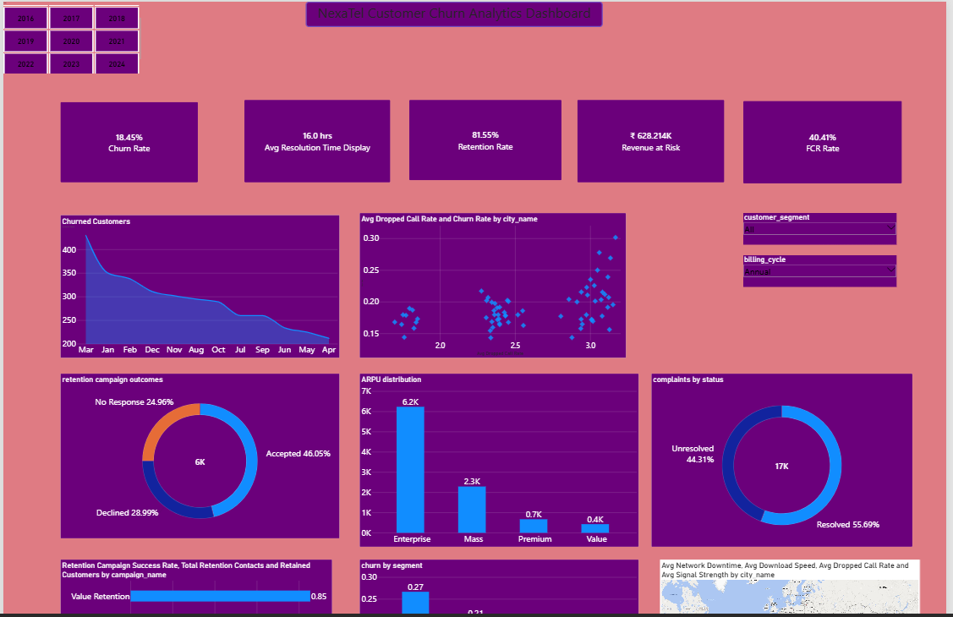
1.Executive Summary
- The NexaTel Customer Churn Analytics Project analyzes approximately 757,000 records across 24 interconnected tables to understand customer churn, retention, customer value, and revenue risk across NexaTel’s telecom operations.
- Applied Python for data cleaning, preparation, validation, exploratory data analysis (EDA), and KPI calculations, while MySQL was used to build a structured relational database and perform business-focused SQL analysis.
- Analyzed key business areas including customer churn, plans and segments, complaints, network performance, geographic churn patterns, customer value, revenue at risk, and retention campaign effectiveness.
- Derived key churn and retention KPIs to quantify customer behavior, identify high-risk segments, and measure the financial impact of customer attrition.
- The final analysis transforms complex customer and operational data into actionable insights for reducing churn, protecting revenue, and improving customer retention strategies.
2.Problem Solved
- NexaTel is experiencing increasing customer attrition, with blended monthly churn rising from 1.9% to 2.7% over four quarters, while customer acquisition costs have increased by 22%, creating greater pressure on customer retention and recurring revenue.
- Customer and operational data was distributed across 24 interconnected tables, making it difficult to obtain a consolidated view of who is churning, why customers are leaving, which customers are most valuable, and how much revenue is at risk.
- The project addressed this by cleaning and preparing the raw data in Python, storing the processed data in MySQL, solving business and analytical questions using SQL, performing EDA in Python, and calculating key churn and retention KPIs.
- This end-to-end analytical workflow provides a structured view of churn drivers, customer risk, revenue exposure, and retention opportunities, enabling management to make more informed and targeted customer-retention decisions.
3.Key Insights
- Aizawl records the highest churn rate at 30.18%, followed by Cuttack at 27.78% and Kollam at 26.92%, indicating significant geographic variation in customer attrition.The concentration of higher churn across these cities indicates a need to investigate location-specific factors such as network quality, service issues, plan suitability, and customer support performance.
- Customers with unresolved complaints record a higher churn rate of 12.21%, compared with 10.64% among customers whose complaints were resolved, indicating a relationship between unresolved service issues and customer attrition.This suggests that faster complaint resolution and proactive follow-up on unresolved cases could support churn reduction, particularly for customers with repeated service issues.
- Accepted responses are the largest retention-campaign outcome at approximately 3,000 customers, exceeding both declined and no-response cases, indicating meaningful customer engagement with retention offers.
4.Business Recommendations
- Prioritize retention efforts in high-churn locations: Focus customer-retention initiatives in Aizawl, Cuttack, and Kollam, where churn rates are highest. Conduct deeper analysis of network quality, complaint patterns, plan suitability, and service performance in these locations and address the dominant local churn drivers.
- Strengthen complaint resolution and service recovery: Since customers with unresolved complaints show a higher churn rate (12.21%) than those with resolved complaints (10.64%), prioritize faster resolution of open cases, establish escalation processes for repeat complaints, and proactively follow up with affected customers.
- Optimize retention campaign effectiveness: With approximately 3,000 customers accepting retention offers, continue using targeted campaigns while measuring whether accepted offers translate into actual retention. Compare offer types, channels, response rates, and retained share to direct spending toward the most effective campaign combinations.
- Develop early-warning churn intervention: Combine indicators such as unresolved complaints, geographic churn patterns, customer value, and campaign response to identify customers showing elevated churn risk and intervene before they leave with targeted service recovery or retention offers.
- Protect high-value customers and revenue at risk: Prioritize retention resources toward high-value customers who also exhibit churn-risk indicators, using personalized plans, loyalty benefits, proactive support, and relevant retention offers to reduce preventable revenue loss.
5.Risks Identified
- First Contact Resolution — 40.41%: Fewer than half of customer issues are resolved during the first interaction, indicating a service-efficiency risk that may increase repeat complaints and customer dissatisfaction.
- Revenue Lost to Churn — ₹25.66 Lakh: Customer attrition is associated with approximately ₹25.66 lakh in lost revenue, highlighting a direct financial impact from customer churn.
- Contract Renewal Rate — 77.65%: Around 22.35% of contracts are not renewed, representing a meaningful risk to customer continuity and recurring revenue.
- Unresolved Complaints — 12.21% Churn: Customers with unresolved complaints show higher churn than those with resolved complaints (10.64%), indicating that delayed or unsuccessful complaint resolution may contribute to customer attrition.
- Geographic Churn — Aizawl 30.18%: Aizawl records the highest churn rate, followed by Cuttack (27.78%) and Kollam (26.92%), highlighting localized retention risk that may require investigation into network quality, service experience, and plan suitability.
6.Opportunities
- Improve first-contact resolution: With First Contact Resolution at 40.41%, strengthen frontline support, agent training, and escalation processes to resolve more issues during the first interaction and reduce repeat complaints.
- Recover revenue through targeted retention: With approximately ₹25.66 lakh in revenue lost to churn, prioritize high-value customers showing churn-risk signals and use personalized plans, loyalty benefits, and proactive service interventions to protect recurring revenue.
- Increase contract renewals: Build on the 77.65% contract renewal rate through timely renewal reminders, personalized offers, auto-renewal incentives, and targeted outreach to customers approaching contract expiry.
- Reduce complaint-driven churn: Since customers with unresolved complaints have a 12.21% churn rate versus 10.64% for resolved complaints, prioritize faster resolution and proactive follow-up to convert service recovery into improved retention.
- Strengthen retention in high-churn markets: Focus targeted interventions in Aizawl, Cuttack, and Kollam, combining network-quality improvements, localized service initiatives, and tailored retention campaigns to address location-specific churn drivers.
7.Tools & Techniques
- Python — Data Cleaning & Quality Analysis & EDA & KPI’s
- MySQL — Analysis
- Power BI — Dashboard

